2025-2026 Winnemucca Pre-K Supply List

- 2 containers of disinfecting wipes
- 1 reem of copy paper
- 2-pack thick, black Expo dry erase markers
- 2-pack thin, black Expo dry erase markers
- 3-pack thick, black Sharpies
- 3-pack Giant Glue Sticks (Disappearing Purple)
- 1 set of Watercolor paints
- 1 container of bubbles
- One re-useable, spill proof water bottle (labeled with name)
- One full change of clothes (pants, shirt, socks & underwear labeled with name in Ziplock bag)
- Diapers/Pull-ups & Wipes (if worn by your child)
- $25 donation to class fund. Make checks payable to “Sarah Winnemucca Elementary School”. Please be sure to indicate that it is for the Early Childhood Class.

AMAZON WISH LIST
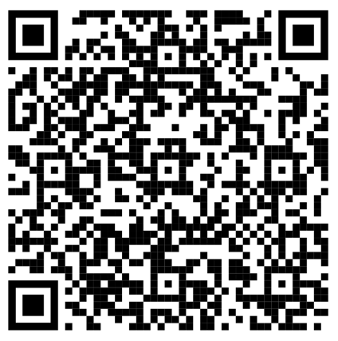

https://www.amazon.com/registries/gl/guest-view/315GUKFKCJ1SY?ref_=cm_sw_r_cp_ud_ggr-subnav-share_A740W3G1EQEGFEC31ZSF_1

If this presents a hardship for you, please provide what you are able.
Thank You!

